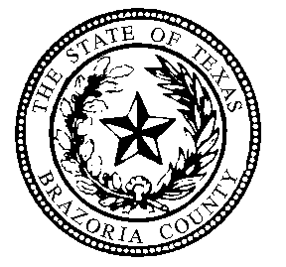

BAIL BOND BOARD

Brazoria County Courthouse 111 E. Locust, Suite 301 Angleton, Texas 77515

NOTICE OF BAIL BOND BOARD CRIMINAL
DEFENSE ATTORNEY REPRESENTATIVE

Beginning Monday, January 14, 2019, the Brazoria County Bail Bond Board will be holding an election for its Criminal Defense Attorney Representative pursuant to Texas Occupations Code § 1704.0535.
Each attorney who has a principal place of business located in the county and who is not legally prohibited from representing criminal defendants in the county is entitled to cast one vote to elect the board member who is a criminal defense attorney. The representative elected must be a criminal defense attorney who is practicing in the county
The ballot box will be located in the Brazoria County Bail Bond Board Office on the third floor of the Brazoria County Courthouse at 111 East Locust Street Angleton, Texas 77515. Ballots may be cast from 8:00 AM to 5:00 PM, Monday through Friday. Please note that the Courthouse will be closed on Monday, January 21, 2019.
Ballots will be accepted until 5:00 PM, Wednesday, February 6, 2019. The results will be canvassed at the Bail Bond Board Meeting at 12:00 PM on Thursday February 7, 2019. For questions, please call (979)-864-1574.

